Session 14 – Training Through a Gaming Format Wei Cui

**Lab Objectives**

1. Go to CyberSecure: Medical Practice
2. Write a report including screenshots and written descriptions. Be sure to include a screenshot and description for step 9.

**Lab Results**

1. Went to https://www.healthit.gov/providers-professionals/privacy-security-training-games.
2. Under Cybersecure: Contingency Planning, clicked Play the Game Now
3. Entered my name and clicked submit
4. Read and listened to the explanation of the game. The opening screen appears as seen in Fig. 1.

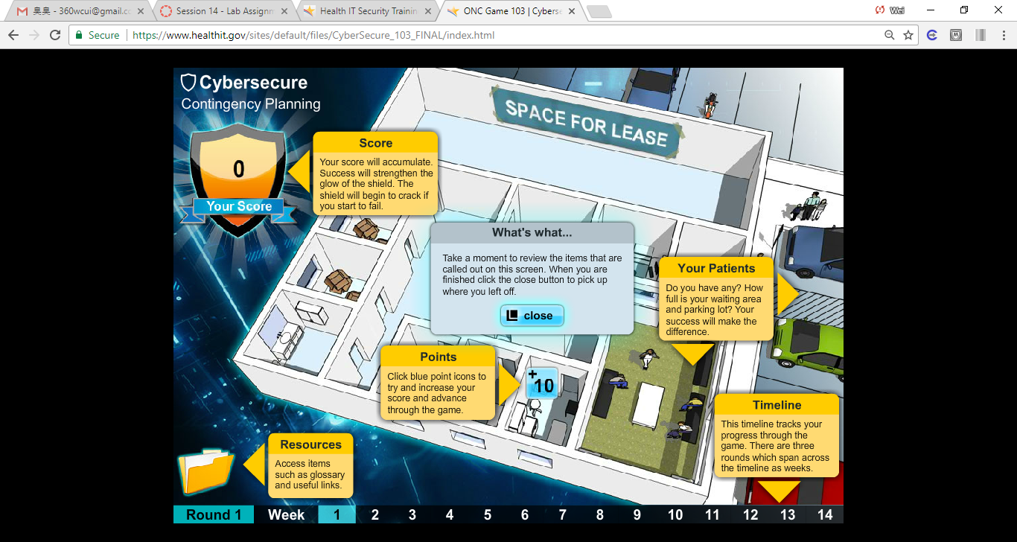

Fig. 1 Opening screen of the contingency planning

1. Read and listened to the information, and then clicked close.
2. Clicked the point icon +10 at the center top of the screen.
3. Read and listened to the question. Clicked make decision as shown in Fig 2.

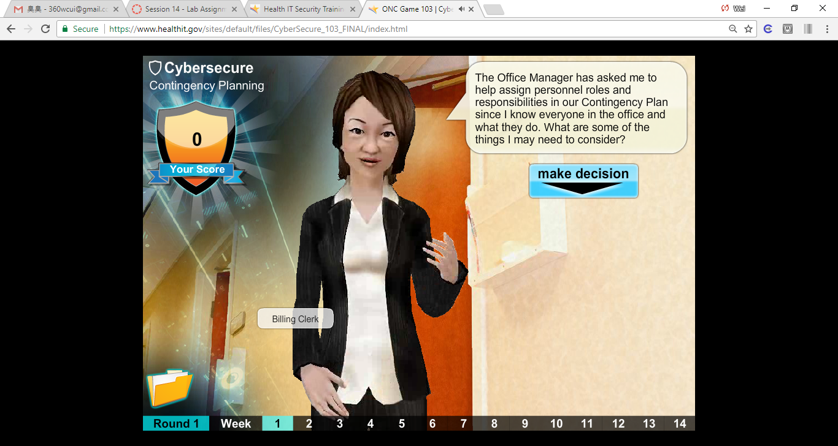

Fig. 2 Read and listened to the question. Clicked make decision.

1. Selected what I think is the right answer as shown in Fig. 3.

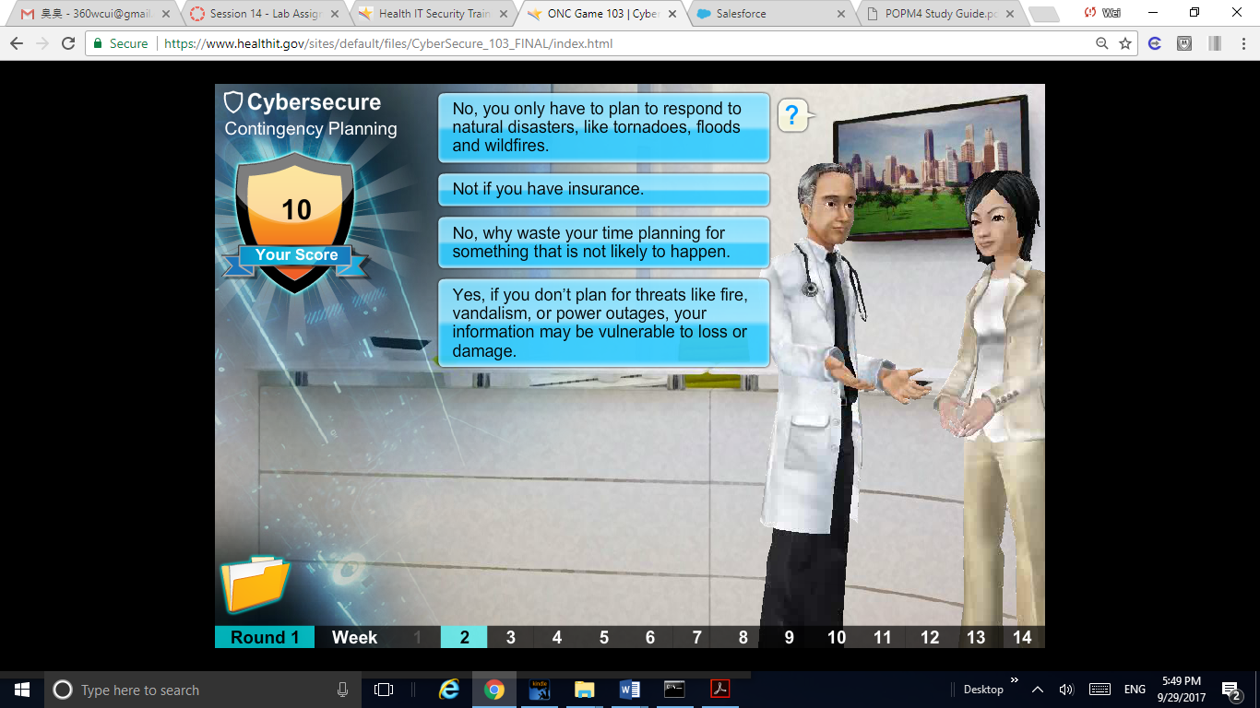

Fig. 3. Selected the answer what I think is correct.

1. If my selection was incorrect, a red “X” is displayed next to that response; if it was correct, a green check mark will display next to it as shown in Fig. 4

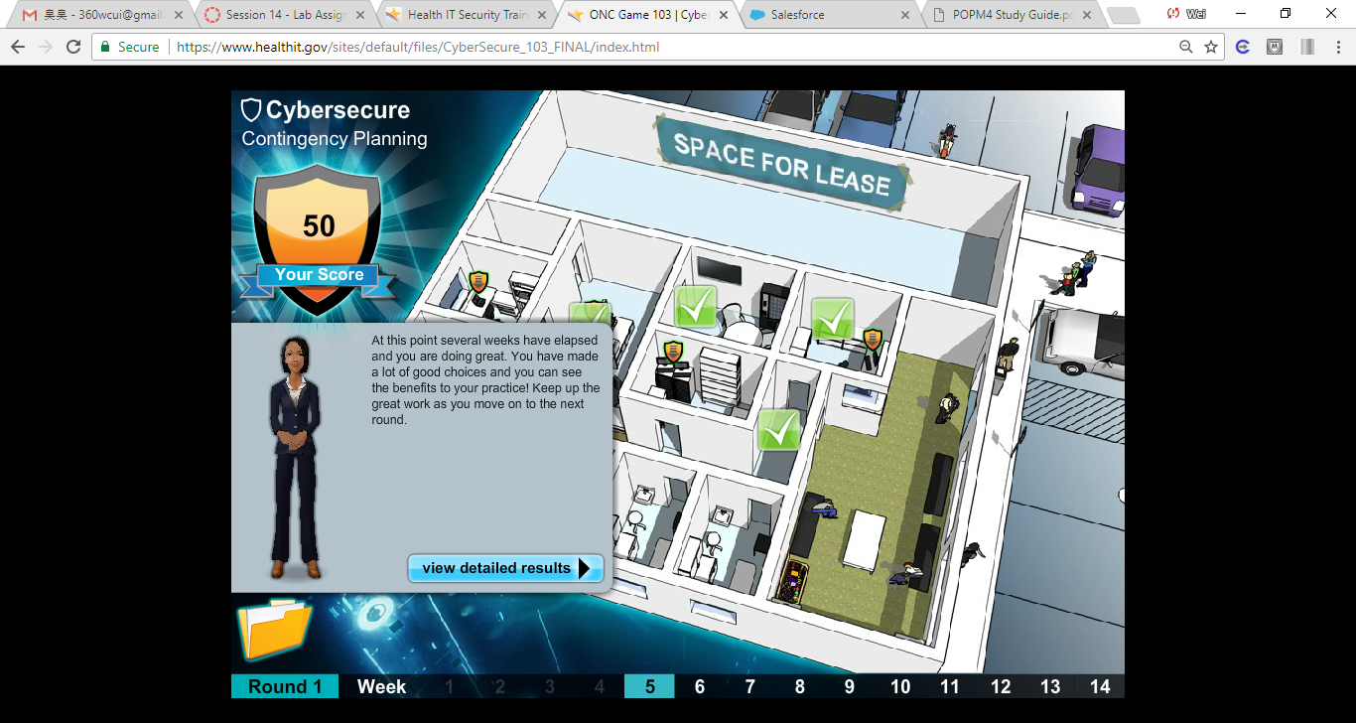

Fig. 4. a green check mark will display next to the correct response.

1. Continued to work through the game; completed the game as shown in Fig. 5.

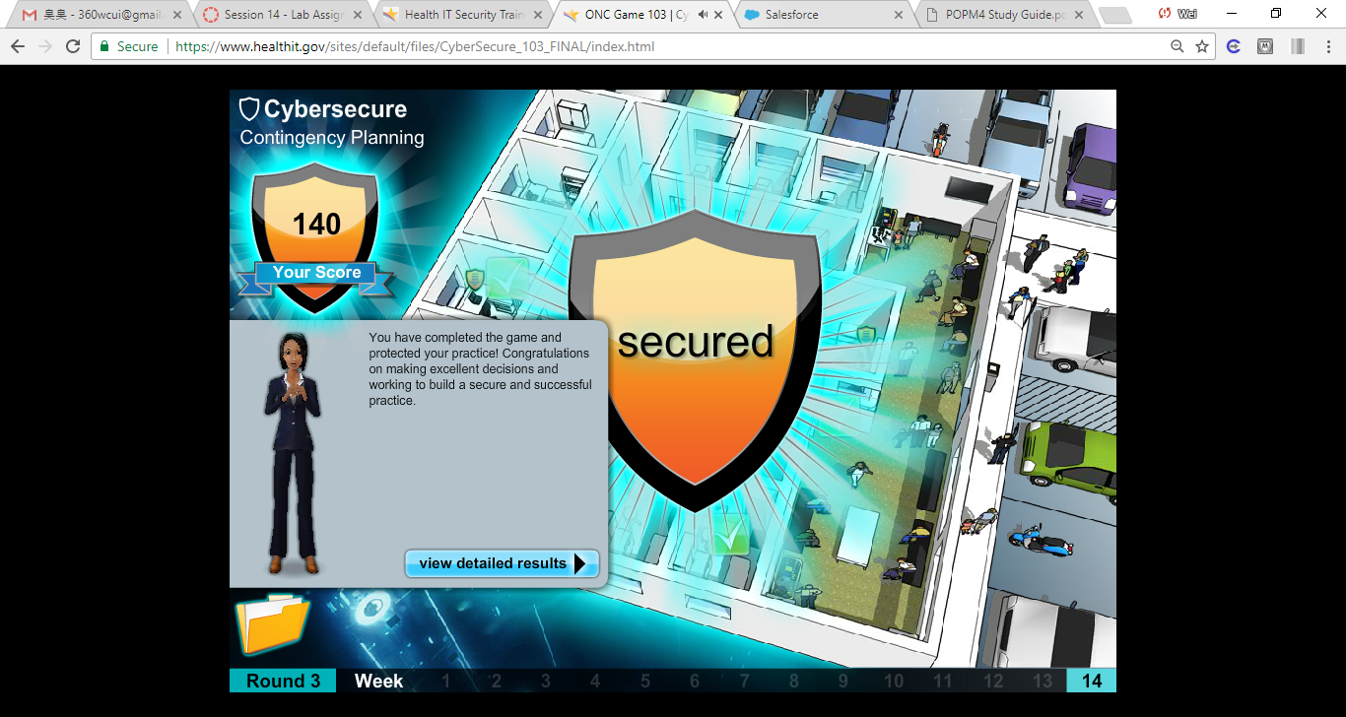

Fig. 5 Completed Contingency Planning.

1. When completed the game, closed to the tab and returned to the main menu.
2. Under Cybersecure: Your medical practice; clicked Play the Game Now
3. Followed the same format to work through the game as shown in Fig.6.
4. What do you think of this type of training format? How does it compare to watching videos as in the previous project? How could it be improved.

This type of training is more interactive than watching videos. It forces me to focus and learn the materials. It can be better improved if the game could be saved so that I could return to where I stopped last time.

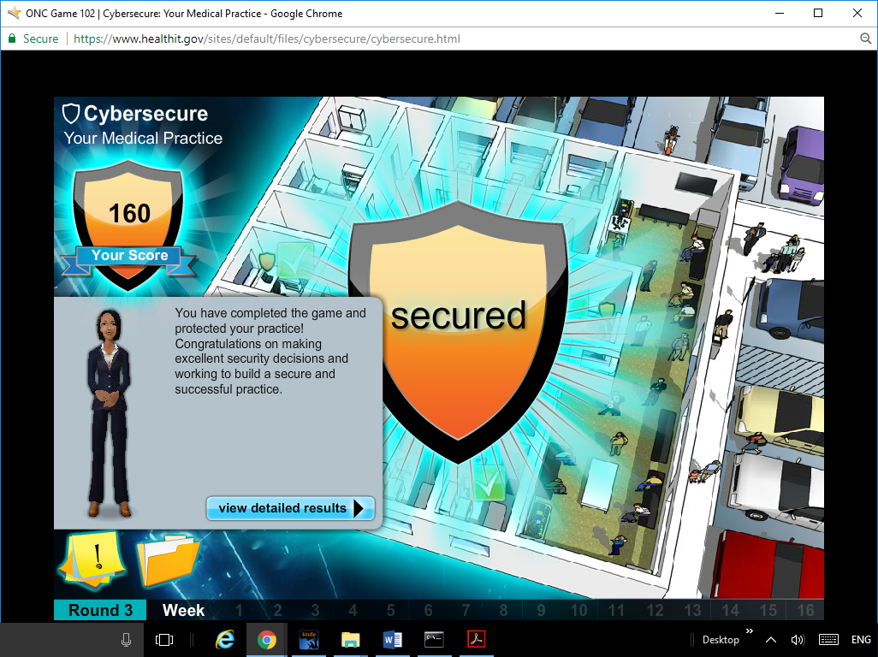

Fig. 6 Completed Your Medical Practice.